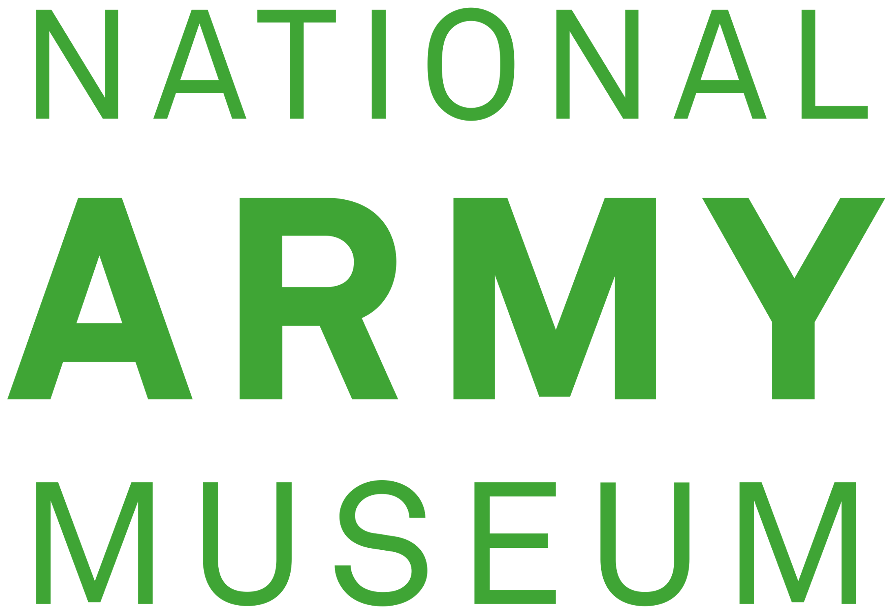
Reprographic Order Form
Templer Study Centre

☐ I am requesting scans or photographs to be taken by the National Army Museum, on my behalf, for research purposes only. I understand that a fee will incur, in line with the Reproduction Policy.

It is important to note that there is a remote order admin fee of £5. Requests up to 10 pages have no additional charge but there is a fee of £1 per page on reproduction requests between 10 and 50 pages. Depending on staff availability and capacity, it may take a few weeks for your reprographic order to be completed.

It is my intention to request copies of the following for non-commercial personal study:

Item accession number | Item description | Number of pages

Staff Use Only

Total number of pages: | Total cost (incl. £5 admin fee):

I DECLARE THAT

- I have not been previously supplied with a copy of the same material by you or any other archive/library.
- I will not use the copy except for research purposes only and will not supply a copy of it to any other person.
- To the best of my knowledge the work had not been published before the document was deposited in your archive and the copyright holder has not prohibited copying of the work. Or if it as has been published, I have not copied more than a ‘reasonable portion’ of the work, e.g. a single chapter or less than 5%.
- If I wish to re-use the material in any way, I will seek permission prior to publication from the National Army Museum picture library for licensing.
- I have read and understood my rights and obligations regarding making copies for personal private study.

Please Sign Below

Name:

Signature:

Date:

Email Address:

Address:

